Part 1
For part 1 of this lab, you will need to open the Resistance in a Wire simulation found here:
https://phet.colorado.edu/sims/html/resistance-in-a-wire/latest/resistance-in-a-wire_en.html
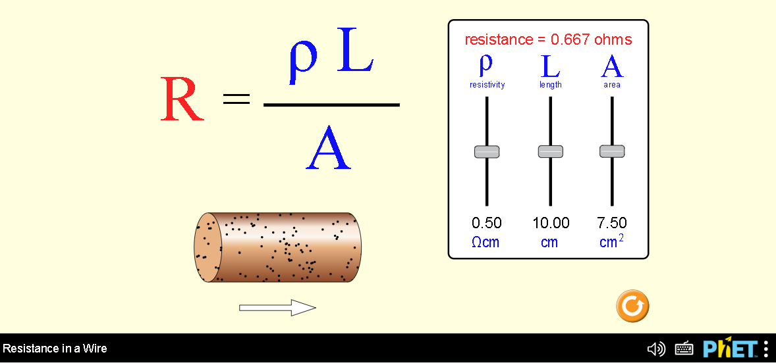
Length
Use the reset at the lower right corner of the screen to bring all values back to the initial values.
- Use the slider for length, sliding it from its’ minimum value to its’ maximum.
  - What happens to the image of the wire in the simulation when it is at a minimum length?
The image of the wire is shrinking to a smaller size
  - What happens to the image of the wire in the simulation when it is at a maximum length?
The image is increasing to larger size in length
- Now look at the equation that is written over the wire. Leave the resistivity and the area at their initial values, and record them here:
  - area = 7.5 cm²
  - Resistivity = 0.5ohm cm
- Keeping those values of area and resistivity constant, record the length and the resistance in the table below. Do at least 5 values of length, and make the range go from approximately 1 cm to the maximum 20 cm.
Length (cm) | Resistance (ohms)
3.07 | 0.205
6.04 | 0.403
9.01 | 0.601
12.13 | 0.809
15.1 | 1.01
18.07 | 1.2
- Now graph the data, with length on the x-axis, and resistance on the y-axis. Include a screen shot.

Looking at the equation for the slope, we are looking at a slope that will be equivalent to rise over run:
$$m=\frac{∆y}{∆x}=\frac{R}{L}$$
Remember, resistance and length are related using our equation:
$$R=\frac{ρL}{A}$$
We will plug this Resistance equation into the slope equation:
$$m=\frac{R}{L}=\frac{(\frac{ρL}{A})}{L}=\frac{ρ}{A}$$
- Is this graph linear? Based on the equation (on the screen in the simulation) for resistance, should this be a linear graph? Explain why or why not.
YES.
Resistance is directly proportional to length. Therefore, change in length will cause a similar change in resistance where the gradient of the resistance equation is ρ/A.
- Plug in the values of resistivity and Area (from #2) into the final slope equation above. How does this compare to the slope of your graph from the trendline?
y = 0.0665x + 0.0016
m= ρ/A. =0.5/7.5≈0.0667
The slope on the graph is slightly lower that generated using the initial figures of resistivity and Area.
Area
- Use the slider for area, sliding it from its’ minimum value to its’ maximum.
  - What happens to the image of the wire in the simulation when it is at a minimum area?
The circumference of the wire is smaller when the area is at minimum point
  - What happens to the image of the wire in the simulation when it is at a maximum area?
The circumference of the is became larger at its maximum area.
- Now look at the equation that is written over the wire. Leave the resistivity and the length at their initial values, and record them here:
  - Length = 10 cm
  - Resistivity = 0.5ohm cm
- Keeping those values of length and resistivity constant, record the area and the resistance in the table below. Do at least 5 values of area, and make the range go from approximately 1 cm² to the maximum 15 cm².
Area (cm²) | Resistance (ohms)
3.04 | 1.64
6.07 | 0.824
9.1 | 0.549
12.01 | 0.416
14.89 | 0.336
- Now graph the data, with area on the x-axis, and resistance on the y-axis. Include a screen shot.

Looking at the equation for the slope, we are looking at a slope that will be equivalent to rise over run:
$$m=\frac{∆y}{∆x}=\frac{R}{A}$$
Let’s manipulate the resistance equation in the simulation, so that we get R/A:
$$R=\frac{ρL}{A}$$
We will plug this Resistance equation into the slope equation:
$$m=\frac{R}{A}=\frac{\left(\frac{ρL}{A}\right)}{A}=\frac{ρL}{A^{2}}$$

- Is this graph linear? Based on the slope equation we just examined for this graph, should this be a linear graph? Explain why, or why not.
NO.
From the graph its evident that resistance is inversely proportional to the area.

- Plug in the values of your resistivity and length (from #8) into the final slope equation above. How does this compare to your trendline equation?
M=$\frac{ρL}{A^{2}}$=$\frac{10×0.5}{A^{2}}=\frac{5}{A^{2}}$
The value obtained from the graph is slightly lower than that calculated using the initial values of resistivity and length.
Resistivity
Use the reset at the lower right corner of the screen to bring all values back to the initial values.
- Use the slider for resistivity, sliding it from its’ minimum value to its’ maximum.
  - What happens to the image of the wire in the simulation when it is at a minimum resistivity?
The number of black dots representing resistivity of the wire is reducing as the resistivity reduce to minimum.
  - What happens to the image of the wire in the simulation when it is at a maximum resistivity?
The number of black dots representing resistivity of the wire is increasing as the resistivity increases to maximum.
- Now look at the equation that is written over the wire. Leave the area and the length at their initial values, and record them here:
  - Length = 10 cm
  - area = 7.5cm²
- Keeping those values of length and area constant, record the resistivity and the resistance in the table below. Do at least 5 values of resistivity, and make the range go from approximately 0.1ohm cm to the maximum 1.0ohm cm.
Resistivity (ohm cm) | Resistance (ohms)
0.2 | 0.267
0.4 | 0.533
0.6 | 0.8
0.8 | 1.07
1 | 1.33
- In this experiment, area and length are the control variables; we don’t change their values throughout. resistivity is the independent variable; we change its value in a controlled way to see how it affects the value of the dependent variable. In this case, resistance is the dependent variable. We will follow the common strategy of graphing the independent variable on the y-axis and the dependent variable on the x-axis. Include a screen shot of the graph you create.

- Following the pattern, we used in the previous two graphs, look at what the slope ought to be equal to, using the resistance and resistivity formula, in equation form. (Follow the strategies we used in #4 and #10.) Show your calculations.
The slope of a curve is given by
$$m=\frac{∆y}{∆x}=\frac{ρ}{R}$$
From the equation $$R=\frac{ρL}{A}$$
$$m=\frac{ρ}{\frac{ρL}{A}}=\frac{ρA}{ρL}$$
$$m=\frac{A}{L}$$
- Is this graph linear? Based on the equation (on the screen in the simulation) for resistance, should this be a linear graph? Explain why or why not.
YES
Resistivity is directly proportional to resistance of the wire with its gradient given by $\frac{A}{L}$
- Plug in the values of length and Area (from #14) into the final slope equation above. How does this compare to the slope of your graph from the trendline?
Slope=$\frac{7.5}{10}=0.75$
The calculated slope is slightly higher than the one derived from the initial values of resistivity and resistance.
Part 2
For this part of the lab, you will be using the Ohm’s Law simulation, which you can find here:
https://phet.colorado.edu/sims/html/ohms-law/latest/ohms-law_en.html

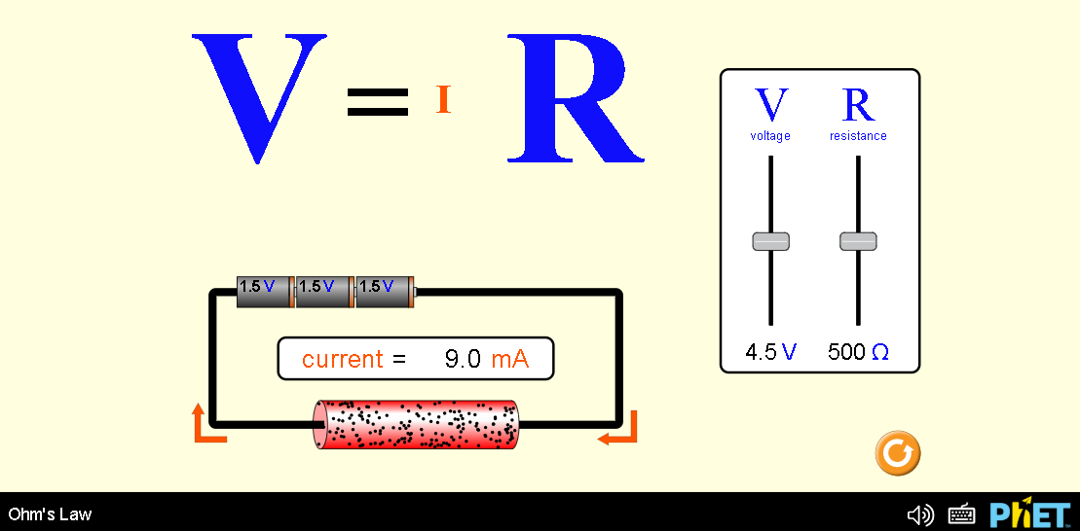

Here, the simulation allows you to connect batteries to a resistor, and measure the current.
- Set the resistance slider so that it has a resistance of 500 Ohms, as you see in the image above. Now we are going to vary the amount of voltage that the batteries supply, and record the amount of current that passes through the resistor. Take at least 5 voltage readings, and record the current that results in the table below. Then convert the current to Amps in the column on the right. Your voltage readings should be spread out over the available range, from 0.1 Volts to 9.0 Volts.
Voltage (Volts) | Current (mA) | Current (A)
1.5 | 3 | 0.003
3 | 6 | 0.006
4.5 | 9 | 0.009
6 | 12 | 0.012
7.5 | 15 | 0.015
- In this experiment, resistance is the control variable; we don’t change its value throughout. Voltage is the independent variable; we change its value in a controlled way to see how it affects the value of the dependent variable. In this case, current is the dependent variable. We will follow the common strategy of graphing the independent variable on the y-axis and the dependent variable on the x-axis. Include a screen shot of the graph you create. Be sure to add a trendline, including the equation of the line, on your graph.

- Following the pattern, we used in the previous parts of this lab assignment, look at what the slope ought to be equal to, using Ohm’s law. How do we write an equation for the current in terms of the voltage and resistance? (Follow the strategies we used in #4 and #10). Show your calculations.
The slope of a curve is given by
$$m=\frac{∆y}{∆x}=\frac{V}{I}$$
From the equation
$$V=IR$$
$$m=\frac{V}{C}=\frac{IR}{I}=R$$
- Using what we know about slope (i.e., slope = change in y over change in x), how would we write an equation for the slope of the line, in terms of current, voltage, and resistance?
V=IR
- How does the equation for the slope of the line you determined in the last question compare to the value of the slope that you got from your trendline?
$$m=R=500$$
Both slopes are equal
- Is this graph linear? Based on the equation (on the screen in the simulation) for resistance, should this be a linear graph? Explain why or why not.
YES.
The voltage of the battery is directly proportional to the current of the supplied the batteries.
- Plug in the value of resistance, which was 500 Ohms, into the final slope equation above. How does this compare to the slope of your graph from the trendline?
Both slopes are equal
- If we increased the value of the resistance to 1000 ohms, what would the slope of a new current vs. voltage graph be? Explain how you got your answer.
The slope would be 1000.
From the equation V=IR, R is the slope and therefore the value of R.

